**Crystal oscillator**

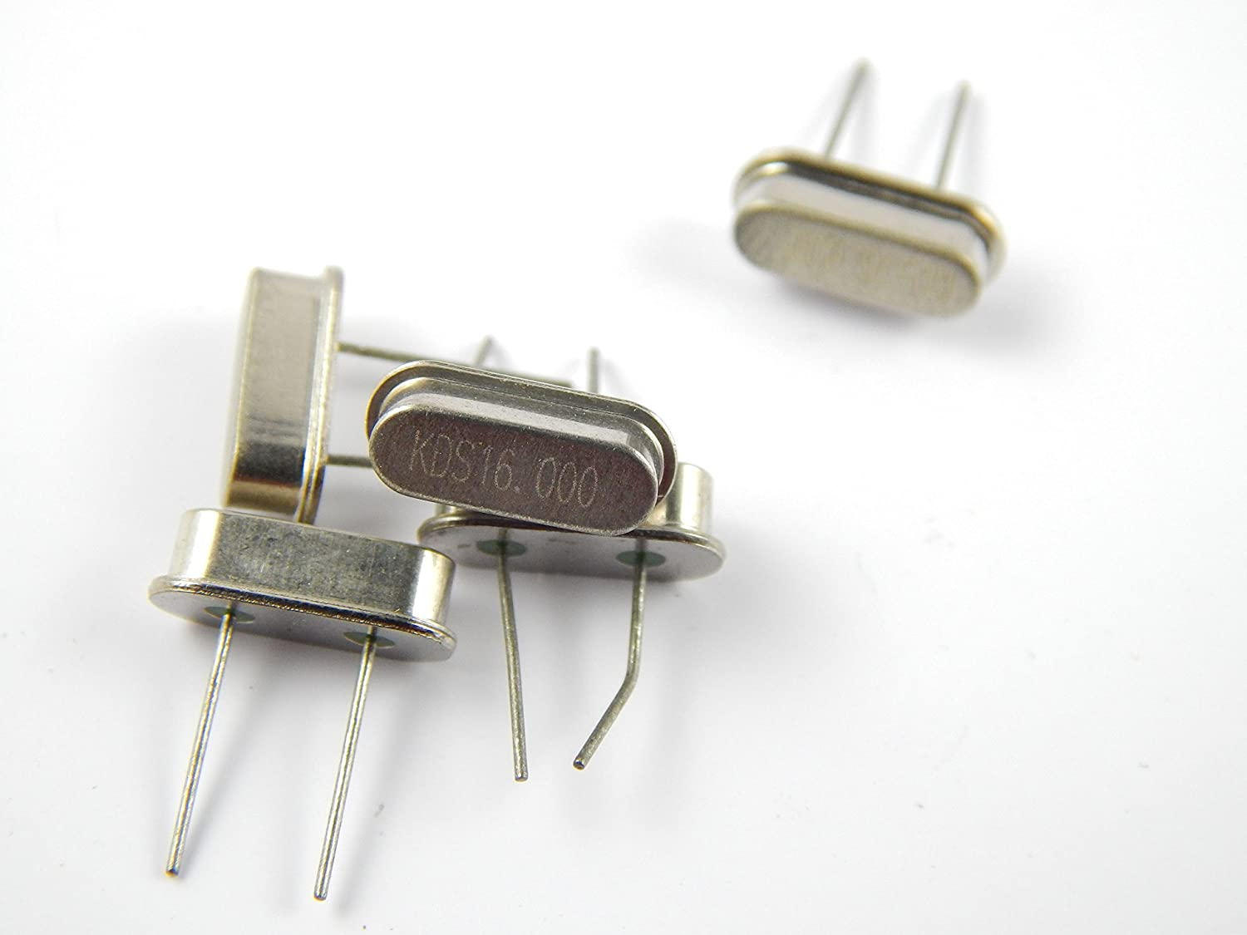

A **crystal oscillator** is an [electronic oscillator](https://en.wikipedia.org/wiki/Electronic_oscillator) circuit that uses the mechanical [resonance](https://en.wikipedia.org/wiki/Resonance) of a vibrating [crystal](https://en.wikipedia.org/wiki/Crystal) of [piezoelectric material](https://en.wikipedia.org/wiki/Piezoelectricity#History) to create an electrical signal with a constant [frequency](https://en.wikipedia.org/wiki/Frequency).[[1]](https://en.wikipedia.org/wiki/Crystal_oscillator#cite_note-Graf-1)[[2]](https://en.wikipedia.org/wiki/Crystal_oscillator#cite_note-Amos-2)[[3]](https://en.wikipedia.org/wiki/Crystal_oscillator#cite_note-Laplante-3) This frequency is often used to keep track of time, as in [quartz wristwatches](https://en.wikipedia.org/wiki/Quartz_clock), to provide a stable [clock signal](https://en.wikipedia.org/wiki/Clock_signal) for [digital](https://en.wikipedia.org/wiki/Digital_data) [integrated circuits](https://en.wikipedia.org/wiki/Integrated_circuit), and to stabilize frequencies for [radio transmitters](https://en.wikipedia.org/wiki/Radio_transmitter) and [receivers](https://en.wikipedia.org/wiki/Radio_receiver). The most common type of piezoelectric resonator used is the [quartz](https://en.wikipedia.org/wiki/Quartz) crystal, so oscillator circuits incorporating them became known as crystal oscillators,[[1]](https://en.wikipedia.org/wiki/Crystal_oscillator#cite_note-Graf-1) but other [piezoelectric](https://en.wikipedia.org/wiki/Piezoelectric) materials including [polycrystalline](https://en.wikipedia.org/wiki/Polycrystalline) ceramics are used in similar circuits.

A crystal oscillator relies on the slight change in shape of a quartz crystal under an [electric field](https://en.wikipedia.org/wiki/Electric_field), a property known as [electrostriction](https://en.wikipedia.org/wiki/Electrostriction) or inverse [piezoelectricity](https://en.wikipedia.org/wiki/Piezoelectricity). A voltage applied to an [electrode](https://en.wikipedia.org/wiki/Electrode) on the crystal causes it to change shape; when the voltage is removed, the crystal generates a small voltage as it elastically returns to its original shape. The quartz oscillates at a stable resonant frequency, behaving like an [RLC circuit](https://en.wikipedia.org/wiki/RLC_circuit), but with a much higher [Q factor](https://en.wikipedia.org/wiki/Q_factor) (less energy loss on each cycle of oscillation). Once a quartz crystal is adjusted to a particular frequency (which is affected by the mass of electrodes attached to the crystal, the orientation of the crystal, temperature and other factors), it maintains that frequency with high stability.

The **16 MHz Crystal Oscillator** module is designed to handle off-chip **crystals** that have a frequency of 4œ16 **MHz**. ... The **oscillator** design generates low frequency and phase jitter, which is recommended for USB operation.

Standard frequency crystals - use these crystals to provide a clock input to your microprocessor.

**Specifications**

•        Frequency: 16 MHz

•        Frequency calibration tolerance: ±50ppm @ 25°C

•        Freq. stability tolerance: ±50ppm from -10° to +60°C

•        Operating temperature: -10°C to +60°C

•        Drive level: <100uW

•        Load capacitance:20pF

•        Shunt Capacitance:<5pF

**16mhz external crystal oscillator**

